Holy Cross Primary School

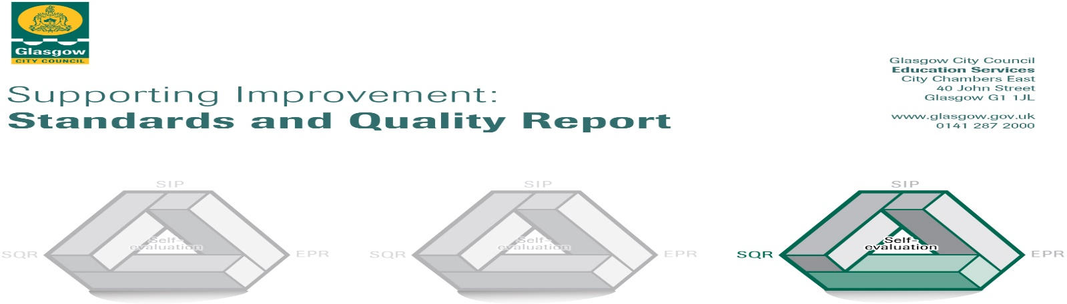

The summary report is provided for parents/careers and partners to outline our achievements this session and our priorities for next session. Throughout this session we have taken forward our priorities as detailed in our school improvement plan. Through our processes of self-evaluation, we have identified how we can improve outcomes for our children and young people.

Our achievements and improvements this year.
Over the course of 2016/17:

- The school was recognised with the Primary Science Quality Mark (PQSM) Gold Award for the quality of Sciences provision and STEM progress and achievements and was achieved within a year.
- Senior school pupils achieved the Scottish Engineering Leaders Award, with some achieving a merit or distinction.
- Children were given opportunities to achieve in a wide variety of settings within school and outwith by taking part in local and national events.
- This session saw the inaugural winners of the Curamus Cup; an award for children who embody the school motto ‘Curamus’.
- Primary 7 pupils won first place at the Holyrood Public Speaking Competition.
- Senior pupils achieved silver and bronze awards in the Scottish Mathematical Challenge.
- Pupils across the school participated in several dance and sport competitions. Success was achieved in, street dance, Scottish country dance, gymnastics, athletics, tennis and badminton.
- Our Primary 6 pupils had the opportunity to achieve success in swimming.
- Our Primary 6 pupils achieved third place in the Glasgow Euro-Quiz.
- All pupils took part in a whole school production, featuring music and dance from the past 25 years.
- Almost a quarter of Primary 3 – 7 pupils attended Big Noise after school clubs.
- A range of after school clubs were provided including: dance, gymnastics, athletics, badminton and netball.
- Primary 7 pupils were supported in their transition to Secondary School through Bridging the Gap and their achievements celebrated at the Bridging the Gap Award Ceremony.
- We continue to embed the nurturing principles across the school. This is supported through our school motto CURAMUS and our core nurture group. Nurture provision was extended to support pupils in the junior school.

School Improvement Planning 2016 – 2017
This year we worked on four areas for improvement. Children, parents, staff and other partners worked together to achieve the following:
- Glasgow Improvement Challenge
The programme of phonics for Primary 1 – 7 was updated and implemented. Pupils from Primary 2 – 7 were assessed in reading using the PM Benchmarking Assessment Resource, giving a reading age for all our learners. New library resources were purchased to supplement the existing book banded libraries. Additional opportunities for reading were provided through the banding of books on Kindles. A phonics glossary and reading skills pack has been developed to support in the teaching and learning of phonics and reading. Targeted support has been provided for pupils to close the attainment gap in reading.

- Digital Technologies
Through engagement with pupils, parents, staff and outside agencies, there has been an increased engagement in home school communication via the newly established school blog. The links established with outside agencies have been effective in raising the profile of digital technologies across the school. In particular, Primary 6’s link with the Glasgow School of Art’s Digital Design Team increased the awareness and enthusiasm towards digital careers. It has also increased skill in digital design which can be evidenced in the project work, with all children producing digital toolkits for Athletics 2018, which will be published for use by children across Glasgow.

- Numeracy and Mathematics
The Glasgow Counts approach to numeracy is being implemented across the school, following a series of CLPL opportunities. Resources have been purchased to support the development of active maths. The weekly Maths Challenge continues to promote challenge in Numeracy. Workshops took place to provide support for parents to support their child’s learning in Numeracy & Mathematics.

- Responsive Planning
A whole school reward system based on promoting positive behaviour was researched and developed. The values which underpin our school motto ‘Curamus’ formed the basis of the new system, and the clear aim was to bring a more consistent approach across the school, with clear guidelines for staff and pupils. Each pupil will have a star chart, gaining stars when they display behaviours reflective of the Gospel values which underpin our school motto. The impact of this will be monitored and measured in the new academic year.
The classroom organisation checklist was reviewed and updated to provide consistency across the school ensuring updated resources are being used in all classrooms.
A welcome pack was created to support the induction of new members of staff, providing a range of valuable information to support them in Holy Cross.

Here is what we plan to improve next year.
- Continue to raise attainment in Literacy through Glasgow’s Improvement Challenge by:
      - Developing a writing approach in partnership with neighbouring schools
      - Providing targeted support to identified pupils in SIMD Band 1 and 2 to close the
attainment gap
      - Providing after school reading and writing activities for Primary 2 – 7 pupils and parents

- Continue to raise attainment across the curriculum, using digital technology to enhance learning and develop children’s digital and employability skills by:
      - Training our pupils to be digital leaders
      - Creating a digital hub, providing a range of technology, including a Promethean Board, Ipads, Kindles and laptops
      - Providing digital after school clubs to engage pupils and parents

- Initiate a Pastoral Care structure to provide enhanced levels of wellbeing by:
      - Consulting with pupils and parents to create and develop a programme of themes for assemblies and classes.
      - Launching a CURAMUS Conference each month where pupil voice representatives meet to lead developments in the school
      - Establish a working partnership with Place2Be

- Develop Early Intervention, Family Support and Scottish Play Strategy by:
- Continuing our effective partnership with Jeely Piece Club to provide opportunities for play and training Play Champs to lead play in the playground
- Delivery of workshops for parents to support their child’s learning
- Play a Long Maths, Literacy and Playing with Sounds workshops

- To plan responsively to new initiatives through the year to ensure approaches are embedded across the school, including:
- Curriculum review through evaluation of curricular planning tools
- Implement of 1 + 2 languages from Primary 1 – 3, with team teaching
opportunities for teachers in the early and first level classes
- Implement and embed God’s Loving Plan throughout the school

How can you find out more information about our school?
Please contact us directly if you require further information or if you wish to comment on the report.

The contact e-mail address is: Headteacher@holycross-pri.glasgow.sch.uk

Our telephone number is: 0141 423 2538

Our school address is: 316 Calder Street, Govanhill, Glasgow, G42 7NH

Further information is available at:
School blog https://blogs.glowscotland.org.uk/gc/holycrosspr/
School website www.holycross-pri.glasgow.sch.uk
Twitter @HolyCrossPri
as well as in monthly newsletters and the school handbook

