[Glasgow City Council - return to homepageGlasgow City Council - return to homepage](http://www.glasgow.gov.uk/)HOLY CROSS

PRIMARY SCHOOL



Welcome to Our School

j0397376



A Curriculum for Excellence

|  |  |
| --- | --- |
| * Literacy and English | * Numeracy and Mathematics |
| * Technologies | * Health and Wellbeing |
| * Sciences | * Expressive Arts |
| * Social Studies | * Religious and Moral Education |

The eight curricular areas

During your child’s first year at school, you will be invited to events which will help you become familiar with the Primary One curriculum.

The purposes of the curriculum are to develop:

|  |
| --- |
| * Successful Learners |
| * Effective Contributors |
| * Confident Individuals |
| * Responsible Citizens |

j0424830DATES TO REMEMBER

|  |  |  |
| --- | --- | --- |
| **Induction Visit** | 10th May/  17th May/  7th June  2023  1.30pm – 2.30pm | Parents to meet Mrs Gray, Headteacher, and Ms Collum, Depute Headteacher for Primary 1 – 3.  Children’s play session to meet other new Primary 1 children, buddies and staff. |
| **Transition Programme** | 7th August – 11th August 2023 | Online Transition programme-  “Meet the Primary 1 Team” – Regular video challenges from the Primary 1 staff for you and your child to take part in and share on our school Twitter page  Access digital content via:  <https://twitter.com/HolyCrossPri> |
| **Parent Workshop 1** | Term 1 (date to follow in new term) | A Guide to using Online Learning Platforms to Support Learning at Home |
| **Parent Workshop 2** | Term 1 (date to follow in new term) | Supporting your child with learning in Literacy and English |
| **Parent Workshop 3** | Term 1 (date to follow in new term) | Supporting your child with learning in Numeracy and Mathematics |
| **Parent Workshop 4** | Term 1 (date to follow in new term) | Supporting your child’s Health and Wellbeing |
| **Parent Workshop 5** | Term 2 (date to follow in new term) | Parents’ Choice Workshop – Parent survey to be completed at the end of Workshop 3 to decide on the theme for this workshop |

j0397242

PRIMARY 1 CALENDAR

**Wednesday 16th August 2023 – Friday 18th August 2023**

9.00 am – 2.15 pm – P1A

9.15 am – 2.30 pm – P1B

9.30 am – 2.45 pm – P1C

9.30 am – 2.45 pm – P2/1

Parents and children assemble in the playground and the children will be invited into class. On the first morning, you are welcome to photograph your own child in the classroom.

**From Monday 21st August 2023**

All children will enter through door 3 at 8.50am.

All children will exit by door 3 at 3.00pm and line up in classes in the playground until dismissed by their class teacher.

**SCHOOL HOURS**

**School starts** – doors open from 8.50am, with lessons starting at 9.00am.

**Primary 1 Playtime** – 10.30am – 10.45 am

**Lunchtime** – 12.15pm – 1.05 pm. Please inform your child’s class teacher if he/she will be going home for lunch.

**School day ends at 3.00 pm** – the children will be dismissed to the playground.

***j0424172***IMPORTANT INFORMATION

HEADTEACHER Mrs C Gray

DEPUTE HEADTEACHER Ms N Collum

DEPUTE HEADTEACHER Ms K McCusker

PRINCIPAL TEACHERS Ms Collins

Mrs Baillie

Mrs Docherty

Mrs Marletta

Ms MacCormick

SCHOOL ADDRESS Holy Cross Primary School

316 Calder Street

Govanhill

G42 7NH

TELEPHONE 0141 423 2538

E- MAIL [Headteacher@holycross-pri.glasgow.sch.uk](mailto:Headteacher@holycross-pri.glasgow.sch.uk)

WEBSITE [www.holycross-pri.glasgow.sch.uk](http://www.holycross-pri.glasgow.sch.uk)

TWITTER @HolyCrossPri



**HOLY CROSS**

**SCHOOL UNIFORM**



Boys

* Grey trousers
* White shirt and tie
* Green jumper

Girls

* Green skirt/Pinafore
* White Shirt and tie
* Green jumper/cardigan
* Full P.E Kit: Yellow polo shirt and bottle green shorts
* Black shoes
* Full P.E Kit: Yellow polo shirt

and bottle green shorts

* Black shoes



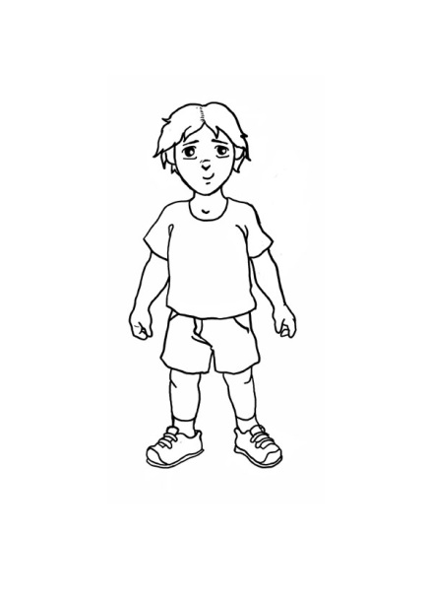Gym kit

* Yellow polo shirt
* Shorts (no football shorts)
* Indoor shoes

*Please remember - no jewellery on gym days!*

All school uniform items are available at Trutex - 35B Argyle Street Station G42 8AH, Telephone 0141 221 4472

Also available online by Set School - Free delivery to your door

www.schoolwearscotland.com

**OUR SCHOOL PRAYER**

God our Father,

Help me to care for all the pupils in our school,

by what I do and what I say.

Help me to use my talents

to fill this school with love and happiness.

Guide and inspire our teachers,

grant wisdom and patience to our parents

and encourage all of us to grow in your love.

Amen

MCj03972640000[1]