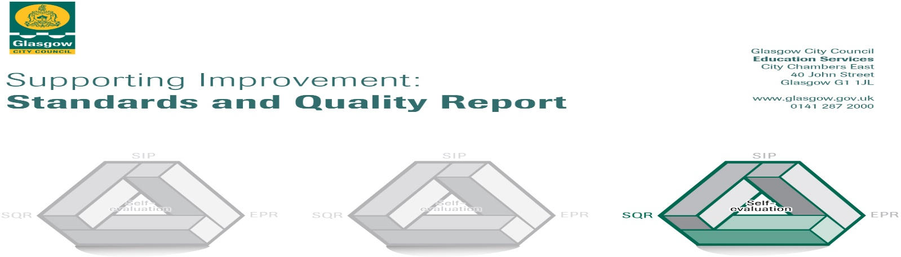

The summary report is provided for parents/careers and partners to outline our achievements this session and our priorities for next session. Throughout this session we have taken forward our priorities as detailed in our school improvement plan. Through our processes of self-evaluation we have identified how we can improve outcomes for our children and young people.

Our achievements and improvements this year.
Key developments (leadership of change) QI 1.3
In session 2018/2019 we made key developments in the following areas by:
- Improving Literacy for All in line with Glasgow’s Improvement Challenge by undertaking a whole school review of the literacy curriculum and introducing a whole school approach to the learning, teaching and assessment of Talking and Listening.
- Developing whole school approaches to Sustainability and Outdoor Education.
- Embedding the skills and knowledge required for the Digital Learning transformation due to take place in Glasgow schools in line with the Connected Learning programme.
- Improving learning and teaching through a whole school commitment to professional learning through the Tapestry programme - Supporting Improvement: Pedagogy and Equity.
- Responding to the needs of the children by maintaining and embedding Play Initiatives and Family Learning Opportunities; implementing a new PE programme; maintaining and extending our Pastoral Care programme.

Developments in learning and teaching and assessment Q1 2.3
Through Literacy for All training, staff were up skilled in the planning, teaching and assessment of talking and listening. Sampling of children’s views indicated increased confidence and development of skills in talking and listening. Engagement and attainment for the targeted groups increased, with assessment evidence showing narrowing of the attainment gap. Pupil Equity Funding was used to purchase new and innovative resources for Teaching and Learning and these were modelled in all classes. School libraries were augmented with new books across all groups. Book banding and colour coding continues to help pupils and parents identify appropriately challenging reading resources. Family learning sessions provided opportunities for parents to support their children through the use of Read, Write, Count materials. A new planning format was devised in collaboration with staff, which will be piloted in session 2019 - 2020.

An evaluation of Outdoor Learning opportunities and understanding of Sustainability was carried out. A plan was devised to work towards achieving Glasgow’s ‘Growing Good Citizens’ award. This will continue into 2019 – 2020. All staff and learners recognise Outdoor Learning as a methodology and have integrated this into practice. As a school we have achieved success by winning 1st place in the Trades House Mini Garden Festival and achieving the Gold Award from The Woodland Trust. A new Global Goals teaching resource was implemented and pupil knowledge and awareness of sustainability has increased as a result. Family learning and engagement was enhanced by a whole school family day out which included sustainability workshops and a single-use-plastic free picnic.

In order to provide a clear and shared approach to the Glasgow City Council’s Connected Learning Programme and Digital Transformation, a Digital Strategy for Holy Cross was developed. As part of this programme all members of the teaching staff received an iPad and the school network was upgraded to support the wireless connectivity of iPads. Almost all staff have received training to support the use of iPads to enhance the quality of teaching and learning experiences for the children. This will continue into session 2019-2020 with the deployment of pupil iPads. Additional resources such as drones, spheros, blue bots and digital accessories were purchased to support digital learning and integrate digital literacy into every area of the curriculum. The ‘Digital Leaders’ developed family learning tools and a Nursery-P1 transition video, as well as a monthly blog competition to increase blog activity, with the aim of improving home/school links. The feedback from children, parents, staff and nursery staff on the leadership of the pupils and support provided across the year has been positive. The Cyber Safety day proved extremely successful in raising awareness of Cyber Bullying and staying safe online with positive feedback from all children. All parents who attended gave positive feedback and requested more opportunities for events on this topic. There are plans in place for further parental information sessions and support for all in the rollout of iPads for children.

The Tapestry Supporting Improvement: Pedagogy and Equity Programme has enhanced teachers’ skill in Assessment is for Learning strategies. Teachers have developed practical ways to increase learner engagement. Staff analysed learning intentions and criteria for successful learning to provide more personalised learning experiences for children. In addition, staff reflected upon and evaluated the types of questioning strategies used with pupils and how, by fine tuning the types of questions asked, children can be further engaged in their learning and identification of next steps. Next session will see staff evaluate and improve upon effective feedback, increased ownership of learning for children and improvement in collaborative learning.

New Physical Education planners have been introduced across the school which have increased teacher’s confidence in providing high quality experiences in P.E. The introduction of Sports Captains has increased confidence and leadership of the children involved in the programme. Increased provision of sporting activities has led to more choice and opportunities for children to participate in sports clubs, events and competitions. The opening of the new Multi Use Games Area (MUGA) has provided more space and opportunity for further increased provision of sporting activities. Following feedback from the Day of Play and staff/parent/pupil surveys the Playground Pupil Voice Committee was able to order new playground equipment and this has increased the opportunities that children have for physical play and activity. The school has submitted an application for a Sport Scotland Gold Award in recognition of the increased provision and participation in sporting activities. Developments have continued in the provision of Learning Through Play in the infant department, with staff receiving further training. Emotions check-ins have been made and will be used across the school next session to promote a whole school approach to understanding emotions and recognising feelings and the benefit of sharing feelings with others.

Here is what we plan to improve next year.
- Glasgow Improvement Challenge – Glasgow Counts and whole school review of the Numeracy and Mathematics Curriculum.
- Literacy- Maintenance and embedding of whole school developments.
- Curriculum – Tapestry Supporting Improvement: Pedagogy and Equity Programme
- Family Learning
- Responsive Planning

How can you find out more information about our school?
Please contact us directly if you require further information or if you wish to comment on the report.

The contact e-mail address is:Headteacher@holycross-pri.glasgow.sch.uk

Our telephone number is:01414232538

Our school address is: Holy Cross Primary School, 316 Calder Street, Govanhill, Glasgow, G42 7NH

Further information is available in: newsletters, the school website, and the school handbook

