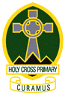
Holy Cross Primary School Uniform

Children should wear full uniform to school every day. School ties are important and identify your child as being a pupil in Holy Cross Primary. Shirt and tie should be worn every day with polo shirts being used for PE only.

School ties are available to purchase in the school office.
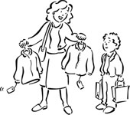

Boys
- Grey trousers
- White shirt and school tie
- Green jumper
- Black shoes
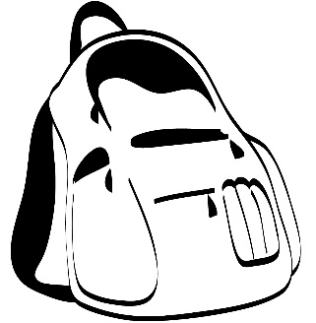

Girls
- Grey/green skirt/dress/trousers
- White shirt and school tie
- Green jumper/cardigan
- Black shoes

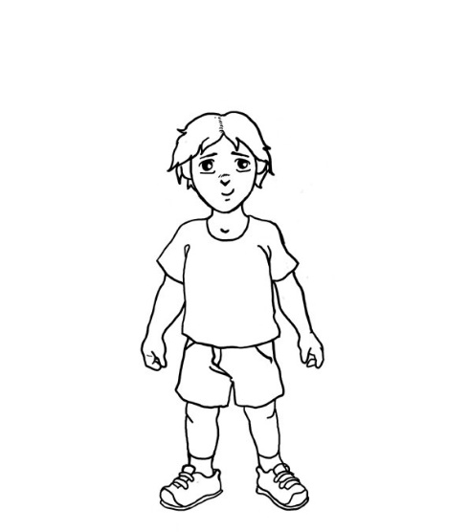
Gym kit
Children will have 2 PE lessons per week – one indoor and one outdoor. PE kits can be brought into school at the beginning of the week and taken home at the end of the week.
- Yellow polo shirt
- Shorts (indoor)
- Jogging trousers (outdoor)
- Indoor shoes
Please remember - no jewellery on gym days!

All school uniform items are available at Trutex - 35A Argyle Street Station G42 8AH, Telephone 0141 221 4472

