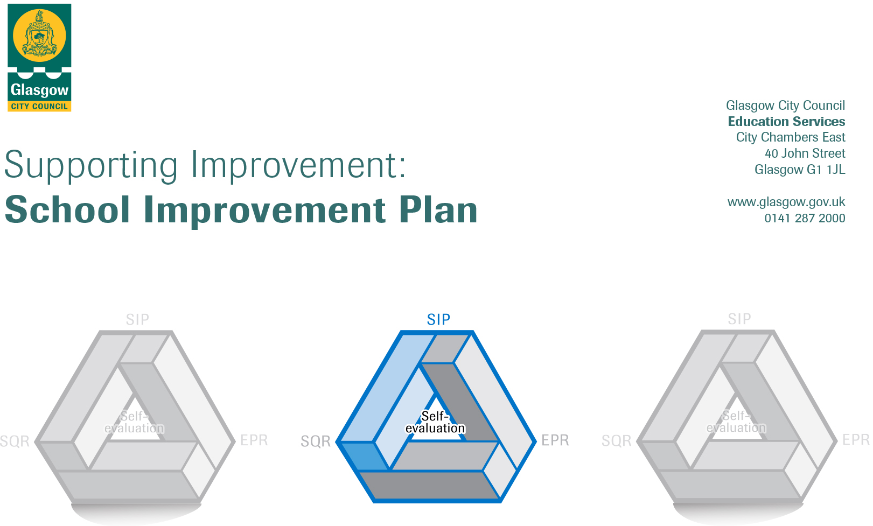

Session: 2019 - 2020

Establishment |  | Holy Cross Primary School
Head of Establishment |  | Claire Gray
Area/Local Improvement Group |  | South LIG 2
Head of Service |  | Donnie MacLeod
Area Education Officer/  Quality Improvement Officer |  | Louise Hamilton Ahara

CONTENTS
1. Vision, Values and Aims
2. Summary of Self-Evaluation Process / Priorities for Improvement in the current session
3. Action Planning

Action Plan Summary for Stakeholders

1. Our Vision, Values and Aims
Our Vision

Within the community of Holy Cross Primary we will be engaged in the pursuit of excellent attainment and achievement for all our pupils. At the heart of our shared vision will be the provision of the highest quality of teaching and learning, the promotion of health and wellbeing and the care and welfare of all learners. The four capacities from Curriculum for Excellence underpin this vision. This provision will take place within an inclusive, nurturing, Catholic ethos where positive attitudes to diversity will continue to thrive. The fulfilment of our vision will be facilitated by partnerships with Parents, Holy Cross Parish, local and wider communities and other agencies.

Our Values
Our Values constitute our school’s moral purpose.
- Our school motto Curamus – We Care encompasses self-respect and respect for each other.
- The Charter for Scotland’s Catholic Schools inclusive of the promotion of Gospel values.
- Children’s voice in the life and work of the school whereby their rights are taken into consideration to facilitate change.
- The highest levels of care and welfare.
- The promotion of health and wellbeing.
- High expectations of attainment and achievement.
- The highest quality learning experiences in order that the children achieve their fullest potential.
- Partnership working.

Our Aims

We aim:
- To ensure that every child achieves the highest standards in literacy and numeracy through high quality learning and teaching.
- To raise attainment by further engaging parents as partners in their children’s learning.
- To ensure that every child has a range of skills for life, preparing them to be part of the young workforce.
- To further develop the skills of all teachers in order to meet the needs of our children.
- Strive to ensure that Holy Cross Primary remains a place to inspire and be inspired.

2. Summary of our self-evaluation process.
Strengths identified:
Self-evaluation is an integral aspect of our approach to continuous improvement. All staff and other stakeholders are actively involved in our on-going self-evaluation activities. The quality assurance calendar supports improvement in teaching and learning and we work collegiately with local cluster schools to complement moderation and share best practice.

We have robust additional support needs procedures, with GIRFEC at the centre, to ensure all children’s needs are met, both academically and pastorally. Effective planning ensures clear learning pathways for children. Through effective assessment and tracking procedures, next steps have been identified for personalised support. Improvements were realised across areas of Literacy. Pupils are encouraged to take increasing responsibility for their learning and are leading developments in digital learning. Pedagogy was renewed to facilitate play based learning and engagement with families. All staff were involved in the self-evaluation of their teaching through the Tapestry SI:PE programme and altered approaches to formative assessment as a result.

Successes and achievements are celebrated through differentiated assemblies and personalisation and choice offered through the Master Class programme. The School achieved a series of awards in Outdoor Learning and is awaiting the outcome of The Sport Scotland Gold Award. The school’s Catholic ethos facilitates a supportive environment for the children.

A wide variety of learning experiences are offered to children throughout the year. Pupils in primaries 3-7 attend Big Noise after school clubs. Dance, gymnastics, athletics, badminton and netball clubs were also provided to enhance Health and Wellbeing. Parent Partnership homework clubs were well attended from P1 to P7 as well as after school clubs to extend pupils digital learning, STEM and development of English language.
Priorities for development:
1: Glasgow Improvement Challenge - Numeracy and Mathematics Curriculum

2: Maintenance of Literacy for all.

3: Family Engagement

4: Tapestry

5. Responsive Planning

3. Action Planning
No | Priority | HGIOS  Quality Indicator | Developing In Faith | Nurture Principles | PEF  Intervention
1 | Glasgow Improvement Challenge – Glasgow Counts  Glasgow Improvement Challenge –Improve attainment in Numeracy and Mathematics. | 3.2  2.2  2.3  2.5 | T2  C1 | 1 | 1

Tasks to achieve priority | Timescale  and checkpoints | Evidence of Impact > (data, observation, views)
Audit of staff CLPL needs | Aug 2019 | CLPL plan for Glasgow Counts and other maths and numeracy aspects.
Audit of current resources | Sep-Oct 2019 | Inventory of resources/Purchase of new resources.
Evaluation of current planning/progression pathways/assessment framework | Aug-Oct 2019 | Staff Voice on new planning resources.  Improvement of planning and assessment framework..
Re-establish maths challenges (weekly/monthly/online) | Aug- Sep 2019  Oct 2019-Ongoing | Increased engagement of challenges/Class teacher observation of pupil engagement/ Increased confidence and accuracy in mental maths/Pupil Voice/ Learning Conversations/ Teacher Evaluations/ Sumdog Data
Plan, deliver and evaluate family learning opportunities, including whole school maths week and increased engagement on social media platforms | Embed across year | Attendance at events/ Feedback forms evidence increased parental understanding of maths curriculum and engagement in children’s learning /Increased social media engagement.
Development and roll out of planning/assessment progression pathways framework. | Oct-March 2019  April 2019 | Consistent and progressive whole school framework/Staff Voice/ pupil experience evaluations and classroom support visits.
Create and deliver a programme of CLPL in line with Glasgow Counts | Oct-June 2019 | Staff Voice/Attendance at CLPL events/ pupil experience evaluations and classroom support visits/Pupil Voice.
Development of teaching approaches for problem solving | Jan-June 2019 | Raised attainment across all curricular areas.
Review SIP actions | May 2019 | Qualitative data to show impact.

Staff leading on this priority – including partners | Resources and staff development
N Collum,C Doherty, R Lochhead, O Corby, F Crossan, S Doherty, Beatrice Ogundipe, Mickdonah Meikleham. | Maths and Numeracy resources  Problem solving resources  Sumdog subscription/CLPL costs

No | Priority | HGIOS  Quality Indicator | Developing In Faith | Nurture Principles | PEF  Intervention
2 | Maintenance and consistency of Literacy for All approaches across the school.  To further develop use of Literacy for All approaches to raise attainment. | 3.2  2.3 | T2  C1 | 1  4 | 2

Tasks to achieve priority | Timescale  and checkpoints | Evidence of Impact > (data, observation, views)
Staff to complete survey of current practice.  Whole school audit of resources. | August 2019 | Data gathered on current practice will provide baseline for planned CLPL opportunities for staff throughout the year. Initial audit of teachers’ confidence in teaching literacy followed by a post-intervention teacher survey.
CLPL opportunities arranged twice termly in reading, writing and talking and listening, in order to cascade information to all staff.  (to include PM Benchmark Assessment) | On-going | Staff will demonstrate an increase in confidence and clear progression of skills and strategies in the teaching of all areas of literacy.  High quality learning experiences for all pupils.  Raised attainment in literacy
Monthly drop in sessions for staff for purposes of advice on practice, resources and moderation. | On-going | Attendance at sessions  Feedback form those in attendance  Raised attainment/Improved teaching and learning
Embedding of Literacy for All reading strategies throughout school | September 2019 – May 2020 | Improved teaching and learning of reading.  Improved book banding results with more pupils attaining within their chronological age.
Embedding of Literacy for All writing strategies throughout school, to include Talk for Writing | October 2019 – May 2020 | Improved teaching and learning of reading.  Improved writing assessment results with more pupils attaining within their age appropriate level.
Embedding of Literacy for All talking and listening strategies throughout school | November 2019– May 2020 | Improved teaching and learning of reading.  Improved writing assessment results with more pupils attaining within their age appropriate level.
Identified staff to work with targeted groups of children to raise attainment in specific areas of literacy, as identified through diagnostic assessment data and professional dialogue. | September 2019 – May 2020 | Data gathered through baseline formative and summative assessment.  Children will demonstrate raised attainment in identified aspects of literacy.
Establishment of a programme of vocabulary assessment, using the British Picture Vocabulary Scale. | August 2019 – June 2020 | Staff will have an increased awareness of the vocabulary abilities of pupils.
Implement the Word Aware Programme across the school to develop vocabulary. | September 2019 | Staff will demonstrate an increase in confidence and clear progression of skills and strategies in the teaching of vocabulary.  High quality learning experiences for all pupils as evidenced in QA events.  Comparison of talking and listening, specifically vocabulary attainment pre and post intervention.
Review and streamlining literacy curriculum, including practice statements in all areas of literacy, to ensure it meets the needs of children and to support high quality teaching of literacy across all stages. | January 2019 | Learning conversations with pupils will show increased motivation in literacy. Staff feedback will evidence increased confidence in teaching literacy.
Parent Workshops arranged in all areas of literacy | September 2019  October 2019  November 2019 | Parents will be involved in supporting children’s education through attendance at workshops. Parental engagement will increase. Increased parental confidence in supporting their child’s learning as evidenced in surveys

Staff leading on this priority – including partners | Resources and staff development
J Collins, P Devlin, D McCrea, A Smith | Printing costs  Replenishment of Book Banded Libraries/Reading Schemes where necessary.

No | Priority | HGIOS  Quality Indicator | Developing In Faith | Nurture Principles | PEF  Intervention
3 | Increasing the positive impact of working with families to improve learning and achievement with a particular view to improving family learning opportunities across all stages. | 2.5  2.3  2.7  3.2 | T2  C1 | 3 | 3

Tasks to achieve priority | Timescale  and checkpoints | Evidence of Impact > (data, observation, views)
Continue with the successful family learning events for P1-P3 as initiated in session 2018 2019. | Sept 2019  On-going | Qualitative and quantitative data showing increased parental engagement and impact on children’s learning.
Carry out an audit to establish areas of good practice within the school and highlight all current opportunities for parental involvement on school calendar. | August 2019 | Data gathered on current practice will provide baseline for planned CLPL opportunities for staff throughout the year. Improved feedback and qualitative data for questionnaires. Collegiality and forward planning of events
Ensure all SIP priorities include a plan for parental engagement. | Aug’ 2019 | Increase number of family learning events across all improvement areas.
Add parental engagement as an on-going item for discussion at department meetings. | Aug’ 2019 | Increased awareness and opportunities for family learning and engagement.
Review and amend current format of ‘Meet the teacher’. | Sept’ 2019 | Increased attendance figures.  Increased engagement by families in children’s learning and knowledge of curricular plan.
Stakeholder survey to establish need and identify areas of improvement in homework, family learning experiences and school events. | Sept’ 2019 | Calendar of events for Parental Engagement to meet the needs of families.  Plan of action identified areas for improvement with particular focus on P4 – 7.
Facilitate staff, pupil and parent consultation on P.L.Ps and use information gathered to develop new system for P.L.Ps. | October 2019 | Highly motivated and actively involved families and children in their own learning and development.
Engage staff in CLPL on how to plan for, implement and evaluate parental engagement. | Jan’ 2020 | Staff have an appropriate shared understanding of Getting it Right for Every Child and use these approaches to meet the needs of families.

Staff leading on this priority – including partners | Resources and staff development
J Baillie, L Marletta , L Brown, S Feeney, J Smith | CLPL, planning for, implementing and evaluating parental engagement  Additional staff cover for events  Resources for events  Home/School resources

No | Priority | HGIOS  Quality Indicator | Developing In Faith | Nurture Principles | PEF  Intervention
4 | Tapestry Supporting Improvement: Pedagogy and Equity | 2.3  3.2 | T2  C1 | 1  4  5 | 4

Tasks to achieve priority | Timescale  and checkpoints | Evidence of Impact > (data, observation, views)
CLPL to refresh outcomes from session 2018 2019 and ensure all staff are up to date on the programme with particular focus on new staff. | August 2019 | Staff access and apply relevant findings from educational research to improve learning and teaching.
Outline dates for continuation of programme as outlined by Tapestry. | August 2019 | Attendance of all staff at Tapestry workshops lead by TLC.
CLPL for all sflw on the pedagogy and strategies implanted in classes. | September 2019 | Support for Learning workers engaged in implementing strategies.  Evident in classroom support visits and TRIO moderations visits.
Update all QA documents to reflect project aims and collate into QA package. | October 2019 | Uniform approach to QA to include formative assessment strategies.
Re-establish Moderation Trios with a view to ensuring professional discussion around formative assessment strategies employed. | September 2019 | Trios Programme within QA calendar with evidence of professional reflection and discussion.  Raised engagement and attainment for children.
Further CLPL events for staff and pupils to showcase strategies to other teachers and parents. | March 2020 | Engagement and feedback from parents and children on strategies employed with the class.
Evaluation of programme to determine further areas for improvement. | March 2020 | Questionnaires for staff, children and parents to show increase understanding of FA and how this impacts on teaching and learning  Raised attainment.

Staff leading on this priority – including partners |  | Resources and staff development
C Gray, J McBride, M D’Arcy, B Ely, C Scally, R O’Neill, F Shankaran, L Anderson |  | Professional reading for all staff  Reprographics  Formative Assessment resources  CLPL
No | Priority |  | HGIOS  Quality Indicator | Developing In Faith | Nurture Principles | PEF  Intervention
5 | Responsive Planning |  | 2.3  3.3 | T2  C1 | 3 | 5

 | Tasks to achieve priority | Timescale  and checkpoints | Evidence of Impact > (data, observation, views)
1. | Review all subject planners identifying where DYW already exists and raise awareness.  Identify gaps in curriculum and draft a plan in order to respond to findings. | August 2019 | External agency evaluations.  Building partnerships with outside agencies.  Increase awareness of DYW and how this is embedded in the primary curriculum.
 | Source new resources in order to add to the Social Subjects curriculum to ensure DYW is built in to every year group. | August 2019 | Improved links with the community and local businesses.  Data to support children’s awareness of the World of Work
 | Create a DYW academic calendar. | September 2019 | All stakeholders aware of events within the life of the school and the opportunities to develop DYW approaches.
 | Implement to World of Work programme from P5 – P7 to support transitions and pupil profiles, including opportunities for family learning. | October 2019 | Child and Parental engagement.  Pupil awareness of skills for Life
2. | Supporting the Connected Learning Programme and the implementation of the pupil Ipad rollout.  - CLPL  - Parental engagement  - Pupil Awareness and skill | September 2019  On-going | Feedback of qualitative/quantitative data to show:  - Pupil skill development in digital technologies;  - Attendance and engagement of families in family learning activities.  - Increased skill in teachers and support staff to engage with digital technologies across the curriculum.
3. | To collate evidence for Growing Good Citizens Award on work being done on Outdoor Learning and Sustainability. | September 2019 | Achievement of Award  Raised awareness with parents, children and staff on sustainability  Increased opportunities for Outdoor Learning
4. | Refreshing approaches to Pupil Learning Plans (PLPs) with a view to improved children and parental engagement in children’s learning. | December 2019 | Children’s ownership of target setting  Parental knowledge on curriculum and targets for children  Liaison with family learning working party to include in calendar of family learning events.
5. | Audit of use of PEF funding to ensure funds allocated to enhance pupil experiences are used across the curriculum. | October 2019  On-going | Plan of PEF funding related to social subject and expressive arts to ensure wider pupil experiences and depth of learning.

Staff leading on this priority – including partners | Resources and staff development
MacCormick ADHT, M Greene, C Kirkwood, C Brannan, J Leyden, Margaret Gray, Eileen McAleer, Grace Sharkey, Silvana Sinclair. | - Contacts with agencies/Businesses, reprographics, CLPL.  - Digital Equipment, CLPL  - CLPL, Celebration of Achievement  - Reprographics  - Costs of Trips as allocated from PEF

