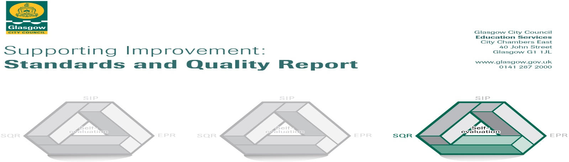
The summary report is provided for parents/carers and partners to outline our achievements this session and our priorities for next session. Throughout this session, we have taken forward our priorities as detailed in our school improvement plan. Through our processes of self-evaluation, we have identified how we can improve outcomes for our children and young people.

Our achievements and improvements this year.
Key developments (Leadership of change) QI 1.3
In session 2022-2023 we made key developments in the following areas:

- Language Communication Friendly Establishment- Whole school approach to the development of Inclusive Practice

- Planning for Assessment- To develop a consistent model for assessment across the school, supporting the planning of learning & teaching.

- Raising Attainment in Literacy – Closing the Vocabulary Deficit through metacognitive approaches.

- Glasgow’s Improvement Challenge Glasgow Counts, Numeracy and Mathematics Curriculum -Maintenance of strategies embedded to raise attainment in numeracy and mathematics.

Language Communication Friendly Establishment
All staff have participated in professional learning on ‘Language Communication Friendly Establishment’ developing their understanding of language across all stages and the importance of environmental factors in developing strong and consistent communication. This has resulted in a reduction in the number of referrals of incidents of dysregulation or emotional distress. A consistent whole school approach to the use of visuals has been established to allow children to access information using a symbols-based language and the displaying of learning and teaching materials has been updated and detailed in a classroom organisation checklist. Most children (79%) said that they can find resources in their classroom and 77% of children said that wall displays help them learn. School spaces have been redesigned to create greater efficacy of space with quiet sensory breakout spaces and the creation of a partnership room.

Planning for Assessment
Following a programme of CLPL, teachers have a consistent understanding of the 4 key strategies for assessment, with a refreshed assessment framework embedded across the school. Periods of holistic assessment to evidence breadth, challenge and application are now incorporated in the school calendar. Using a fact, story, action approach teachers in all settings use robust diagnostic assessment data to identify strengths and interventions. Using this assessment data teachers are empowered to lead change in their setting by augmenting the curriculum, addressing the balance of the curriculum and directing support to meet learners’ needs.

Planning for assessment is now incorporated in all curricular planners to ensure that assessment is integral to our planning of learning and teaching. Staff professional judgements have been validated through our in-house moderation trios programme. By looking outwards, across our learning community, staff have had collaborative opportunities to moderate using the learning and teaching cycle.

Raising Attainment in Literacy
A whole school approach to improving children’s vocabulary was undertaken over the past 2 years. Universal and targeted offers were implemented across the school. Universally, the majority of children have increased their vocabulary age. Consistent pedagogy has resulted in improvements in talking and listening with significant gains in Primary 7.

Glasgow’s Improvement Challenge Glasgow Counts, Numeracy and Mathematics Curriculum
Glasgow Counts, CPA (Concrete, Pictorial, Abstract) strategies have been embedded in every class leading to increased consistency in learners’ experiences in numeracy. Most of the children (73%) who attended targeted intervention groups (TIGs) are now on track and the attainment gap for them has been closed. Through learning conversations children have expressed that they feel more confident during numeracy lessons and can apply the GC strategies. Practitioner knowledge and confidence in the teaching of Numeracy and using Glasgow Counts Strategies has increased, leading to improved learner experiences as evidenced in the Quality Assurance Programme.

Here is what we plan to improve next year.
- To improve attainment in literacy and numeracy across the school - Review writing assessment framework across the school and embed consistent approach to problem solving across the school
- To ensure equity and inclusion for all - To develop a Language Communication Friendly Environment and to refresh schools approaches to promoting positive behaviour and respect
- To improve assessment and targeted intervention of children’s Health and Wellbeing

How can you find out more information about our school?
Please contact us directly if you require further information or if you wish to comment on the report.

The contact e-mail address is: Headteacher@holycross-pri.glasgow.sch.uk

Our telephone number is: 0141 423 2538

Our school address is: Holy Cross Primary School, 316 Calder Street, Govanhill, Glasgow, G42 7NH

Further information is available in: newsletters, the school website, the school Twitter and the school handbook

