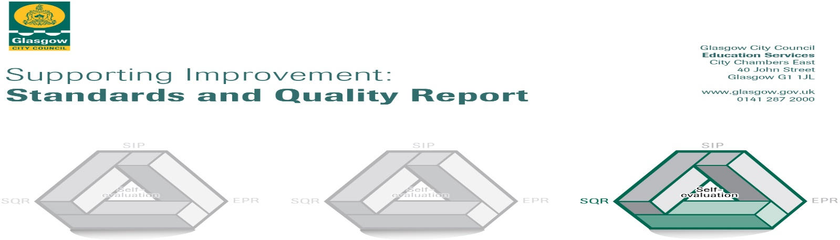
The summary report is provided for parents/carers and partners to outline our achievements this session and our priorities for next session. Throughout this session, we have taken forward our priorities as detailed in our school improvement plan. Through our processes of self-evaluation, we have identified how we can improve outcomes for our children and young people.

Our achievements and improvements this year.
Key developments (Leadership of change) QI 1.3
In session 2021-2022 we made key developments in the following areas:
- Improving Our Classrooms – A Whole School approach to improving Learning and Teaching
- Word Aware – Developing vocabulary to strengthen pupil voice and raise attainment using metacognitive strategies.
- Glasgow’s Improvement Challenge Glasgow Counts, Numeracy and Mathematics Curriculum
- Family Learning
- Health and Wellbeing – Emotion Works – Reinforcing a common language around personal and community wellbeing as well as developing key partnerships with other agencies.

Improving Our Classrooms Whole School Model
This whole school project produced positive results in children’s literacy, in particular, their knowledge of vocabulary, with all children within the targeted intervention groups making significant gains. Teaching staff became more reflective practitioners due to engaging in trio discussion groups; completion of a journal throughout the year exploring and reflecting on the areas of highly effective practice, and the high quality pre and post webinar discussions. Staff have a renewed appreciation that data informed self-evaluation is a vital tool in improving children’s achievement and attainment. Teaching staff conducted a ‘Fact, Story, Action’ tracking approach where they analysed their class data and identified any barriers to learning as well as ‘the gap’ in their classroom which served to inform planning and empower staff.

Developments in Ensuring Wellbeing, Equality and Inclusion QI 3.1
The engagement of staff and children in awareness of Nurture Principles and the application of these within the life of the school community was driven through staff meetings and assemblies. A whole school assessment of wellbeing was undertaken using Glasgow’s Motivation and Wellbeing Profile. From this assessment, and ongoing rigorous tracking, children across the school were identified for class-based or further agency support. Nurture staff liaised with teachers in identifying children for targeted nurture support with all staff participating in training in Emotion Works, to develop a common language for all pupils in emotional literacy. In support of resilience planning, partnerships were strengthened with many agencies including, Quarriers, Place2Be, Operation Play Outdoors, YCSA, Govanhill Community Development Trust, The Space Govanhill, Young Carers Service and Queens Park Football Club. All children engaged in Operation Play Outdoors sessions, with P4-P7 achieving The John Muir Discovery Award. In order to further support reconnection, existing communication pathways such as newsletters, Twitter and the school website were re-established and augmented to include translated audio messages in the 7 main languages. Furthermore, curricular videos and agency information were added to the school website to provide a support hub for families, which will be extended in the coming year.

Developments in Learning, Teaching and Assessment QI 2.3
A more robust planning framework for Maths and Numeracy has been embedded across the school, in line with Glasgow Counts pedagogy. Further training events on the use of new planning formats were well attended by staff with surveys highlighting that most teachers (85%) found the CLPL sessions and resources extremely useful in improving children’s learning experiences in numeracy. Pupil Equity Funding was used to purchase new and innovative resources for numeracy and mathematics, and the CLOL worked closely with the Family Learning Co-ordinator to create an additional series of videos to support the use of the resources contained in the ‘Maths Mastery’ kits, piloted in P4. Within Numeracy targeted intervention groups, all children (100%) made improvements towards closing the gap between their chronological age and maths age. Most children in group 1, (75%) managed to close the gap completely and now have a maths age higher than their chronological age and in group 2, the majority (50%) have managed to close the gap completely and now have a maths age higher than their chronological age.

Developments in Family Learning QI 2.5
Universal and targeted supports have been successful in re-establishing family learning and digital content was created to replace face to face parent workshops. The majority of P1 families engaged with online induction workshops; with feedback stating that parents who engaged felt more confident and informed to support their child’s learning at home. A few families requested content they would like us to create and we were able to accommodate this with maths support videos. Provision of devices, with support and translated instructions, have meant more of our families can engage with digital content.
The appointment of a Family Support Worker enabled us to provide advice to families in financial hardship and support technical or administrative processes. Our Family Support Worker has been able to help our families access family learning opportunities and develop translated content for our digital platforms. Maths week, COP26 activities and World Book Day provided online challenges with feedback from parents and children evidencing enjoyment and offering suggestions for future challenges.
We were able to re-establish some face to face family learning with our partners at Operation Play Outdoors and Jeely Piece Club who led outdoor sessions with small groups around themes of STEM and Health & Wellbeing. Feedback indicates that all stake holders enjoyed these sessions and would participate again. Children also reported on which activities from these sessions they would try at home, and families gave ideas to inform our next steps.

Here is what we plan to improve next year.
- Language and Communication Friendly Establishment school award.
- Word Aware – Continue to develop vocabulary to strengthen pupil voice and raise attainment with effective metacognition strategies.
- To continue to embed Glasgow Counts strategies and pedagogy across all classes
- Health and Wellbeing – Work with Queens Park Football Club as a partnership school. Continue to embed Emotion Works from P1-P7. To continue to enhance our internal pathways of support.

How can you find out more information about our school?
Please contact us directly if you require further information or if you wish to comment on the report.

The contact e-mail address is: Headteacher@holycross-pri.glasgow.sch.uk

Our telephone number is: 0141 423 2538

Our school address is: Holy Cross Primary School, 316 Calder Street, Govanhill, Glasgow, G42 7NH

Further information is available in: newsletters, the school website, the school Twitter and the school handbook

