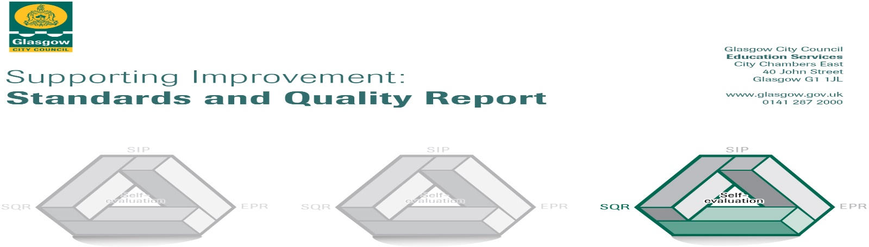
The summary report is provided for parents/carers and partners to outline our achievements this session and our priorities for next session. Throughout this session, we have taken forward our priorities as detailed in our school improvement plan. Through our processes of self-evaluation, we have identified how we can improve outcomes for our children and young people.

Our achievements and improvements this year.
Key developments (Leadership of change) QI 1.3
In session 2023-2024 we made key developments in the following areas:

- Language Communication Friendly Establishment- Whole school approach to the development of Inclusive Practice
- Promoting Positive Behaviour and Respect- Whole school focus on developing practice with a rights focussed lens and reducing incidents of perceived or real bullying.
- Raising Attainment in Literacy – Closing the attainment gap in writing in P1 to P7 through improved pedagogy and assessment in writing.
- Approaches to Maths and Numeracy Problem Solving Across the School -Developing consistency in approaches to maths and numeracy problem solving, with a focus on word problems.

Language Communication Friendly Establishment
All staff have participated in further professional learning on ‘Language Communication Friendly Establishment’ and use of symbol language in developing consistent communication across the school. A consistent approach to displays and signage has been embedded throughout the school, with all classes using the same muted colours for wall displays across curricular areas. This has been reflected within the signage to support children’s independence in accessing resources and wall displays within the classroom. Greater use of visuals, specifically symbols, has been embedded in all classroom signage with some staff also using symbols to support curricular resources. There has been an increase in staff using visual lanyards within classrooms and this will continue to be developed in the next academic year. The impact of this development was noted by HMIE in a recent inspection where they stated that staff have applied their professional learning very well to create a language and communication friendly environment across the school. They noted that staff use displays highly effectively within the classrooms to support learning. Teachers have developed learning environments which are well organised, inclusive and calm. Children participate and are supported very well in lessons, as a result. They use consistent language and visuals effectively to help children for whom English is a new or additional language understand what they will be learning.
Further work around TALK practices will be undertaken in the next academic year to gain accreditation as a Language Communication Friendly Establishment.

Promoting Positive Behaviour and Respect
All staff have completed online training modules for Respect Me anti bullying approaches. This has ensured a consistent approach to recognising and responding to bullying behaviour. Increased rigour in the recording of negative behaviour has been used to support analysis and explore trends in bullying behaviours, in order to develop early intervention strategies to support a reduction in bullying behaviour. Children attended a drama performance around bullying to open discussions and allow children to consider the impact of bullying. This supported the children’s understanding of The United Nations Rights of the Child (UNCRC) which are promoted explicitly and consistently throughout the school. HMIE recognised that staff have a shared understanding of children’s rights and use the language of this. They noted that children are developing their confidence in discussing children’s rights and what this means for them.
Pupil Voice has been re-evaluated and a new format introduced this year bases on HGIOUR School guidance. Children have explored, discussed and gathered data on the areas of Our Relationships, Our Learning and Teaching, Our School and Community, Our Health and Wellbeing and Our Successes and Achievements. Pupil Questionnaires were collected and analysed on each of the areas and an action plan put in place to address the issues raised by the children. Pupil voice post boxes were installed in every classroom and common area. The success of our developments in this area were noted by HMIE who stated that pupil voice is a key driver in this programme and groups of children have been established to be involved in this work.

Raising Attainment in Literacy
All staff have been trained in the 'Routes through Writing' assessment tool which will be introduced into practice next year. 92% of staff reported undertaking professional development or training related to the ‘Literacy for All’ genre approach over the past year and 88% collaborated with colleagues to share strategies or experiences related to teaching writing using the genre approach, with significant positive impacts reported. Almost all staff have reported to having developed a very good/excellent understanding of the genre approach to teaching writing and most staff have incorporated the ‘Literacy for All’ genre approach and associated strategies, into their writing lessons weekly.
Children across the school have responded well to the programme with the majority of children in Primary 5 reporting that their attitude towards writing has changed this year with 60% of children feeling ‘somewhat more positive’ or ‘much more positive’ towards writing. 85% of the children stated that they find it easier to know what to write since learning about the different genres and 72% of children indicated feeling more comfortable sharing their writing with others now compared to before learning about the genres. This is also reflected through pupil voice in Primary 7 which noted similar levels of improvement. The programme will continue to be rolled out across Primary 3 to Primary 7 in the next academic year with Foundations of Writing to be rolled out for Primary 1 and Primary 2.

Approaches to Maths and Numeracy Problem Solving Across the School
All staff have participated in professional learning in Cognitively Guided Instruction (CGI) in maths in order to deepen knowledge and awareness of the different ways in which children approach numeracy and maths problems. Staff have developed a deeper understanding of problem types and a greater awareness of the value of children’s natural problem solving abilities. Staff have trialled counting and problem solving approaches rooted in the theories discussed and shared their findings with the wider staff team. Staff feedback suggested that within small group work, children displayed an ability to develop their own problem solving strategies which were then able to be nurtured and developed to good effect. Children were also able to create their own problems based upon the word problems given, further highlighting the positive impact of this approach on the children’s learning and their ability to apply problem solving skills in new contexts.
Staff learning and application of CGI will be continued in the new academic year in order to build greater consistency and further strengthen the problem solving skills of children across the school.

Here is what we plan to improve next year.
- Close the attainment gap in writing in P1 to P7 through improved pedagogy and assessment in writing.
- To develop a Language Communication Friendly Environment with formal accreditation.
- To refresh schools approaches to promoting positive behaviour and respect underpinned by UNCRC

How can you find out more information about our school?
Please contact us directly if you require further information or if you wish to comment on the report.

The contact e-mail address is: Headteacher@holycross-pri.glasgow.sch.uk

Our telephone number is: 0141 423 2538

Our school address is: Holy Cross Primary School, 316 Calder Street, Govanhill, Glasgow, G42 7NH

Further information is available in: newsletters, the school website, the school Twitter and the school handbook.

